DAILY ONLINE ACTIVITIES SUMMARY

|  |  |  |  |  |  |  |  |
| --- | --- | --- | --- | --- | --- | --- | --- |
| **Date:** | **15-06-2020** | | | | **Name:** | **Kavya.R.Shetty** | |
| **Sem & Sec** | **6th Sem ‘A’ Sec** | | | | **USN:** | **4AL17CS042** | |
| **Online Test Summary** | | | | | | | |
| **Subject** | | **C programming Quiz and python workshop quiz** | | | | | |
| **Max. Marks** | | **--** | | **Score** | | **--** | |
| **Certification Course Summary** | | | | | | | |
| **Course** | **Workshop exercise solving** | | | | | | |
| **Certificate Provider** | | | **--** | **Duration** | | | **--** |
| **Coding Challenges** | | | | | | | |
| **Problem Statement: 2 programs** | | | | | | | |
| **Status: Executed** | | | | | | | |
| **Uploaded the report in Github** | | | | **yes** | | | |
| **If yes Repository name** | | | | <https://github.com/kavya-shetty765/DAILY-> [STATUS](https://github.com/nandithashetty/DAILY-STATUS) | | | |
| **Uploaded the report in slack** | | | | **yes** | | | |

# Class and Quiz Snapshots: C programming:

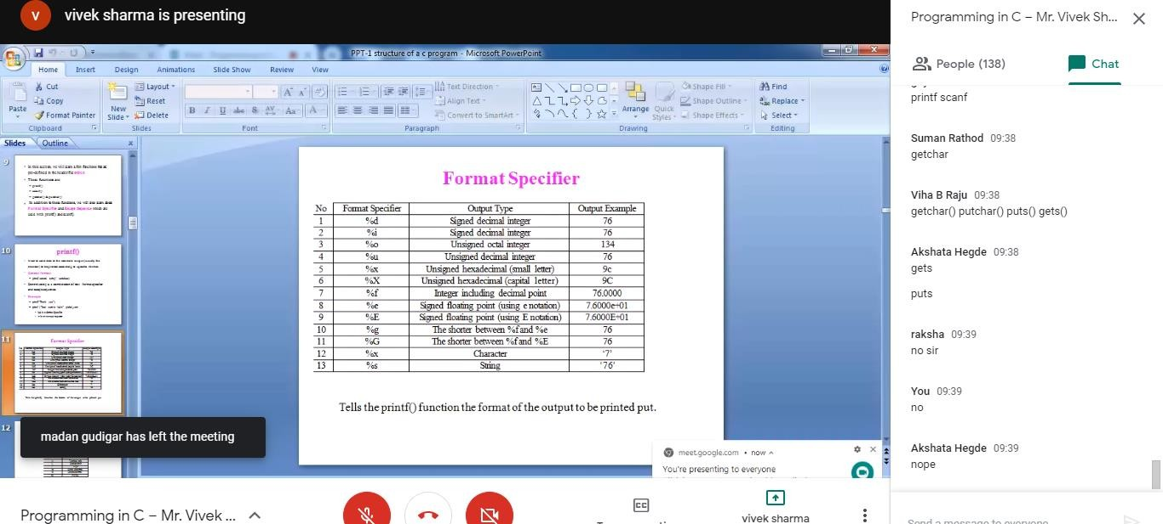

**Python workshop :**

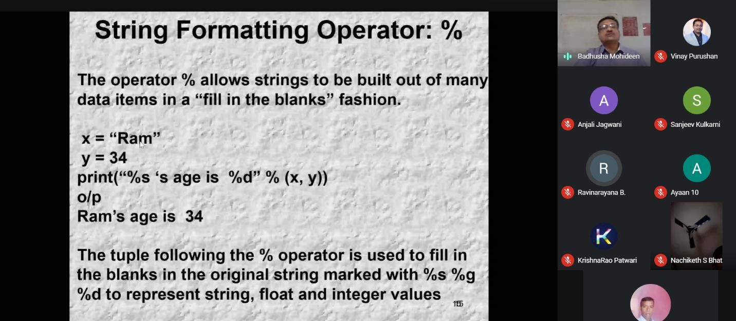

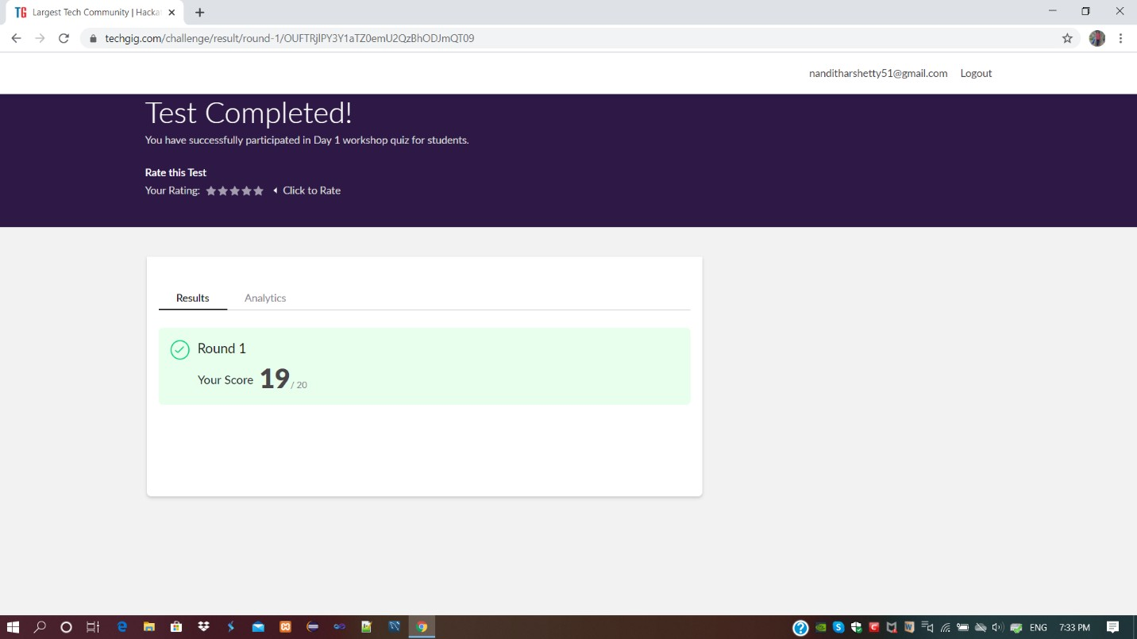

Refer the github link for **example programs and exercise programs**:

github.com/kavya-shetty765/Appilications-of-Python-Programming-in-DA-and-ML

# Coding Challenges Details:

Refer the github link for detail information :

<https://github.com/kavya-shetty765/DAILY-STATUS/tree/master/15-06-> [2020/ONLINE%20CODING](https://github.com/nandithashetty/DAILY-STATUS/tree/master/15-06-2020/ONLINE%20CODING)

This Report is also available in:

<https://github.com/kavya-shetty765/DAILY-STATUS/tree/master/15-06-2020>

# C programming exercise solved in:

<https://github.com/kavya-shetty765/PROGRAMMING-IN-C>